**Project Management Workbook**

This material will introduce you to general terms and concepts associated with project management (PM).

When you begin working for a specific organization, you will likely find that these terms and the way they are used may be different at your organization.

**Defining Project Management**

| Defining what constitutes a project | A project is an individual or collaborative enterprise that is carefully planned to achieve a particular outcome. |
| --- | --- |
| Greenfield | new implementation |
| Brownfield | System conversion |
| Project Management | The process of managing all activities required to successfully complete a project. |

Project Management Result Keywords

| On time | | Within Budget | Appropriate Quality |
| --- | --- | --- | --- |
| Project Manager | The person responsible for managing the process and the activities of project management. | | |
| Project Charter | A document that provides formal approval to proceed as a project | | |
| Project Schedule | How the project shows key milestones and their progress | | |
| Gantt Chart | A way to show project milestones/activities to be completed and timing. Shows visually what will be happening and when | | |

**Planning**

1. Determine the viability of the proposal. Will the final product create enough value to pay for the project costs and give the organization enough benefit (return on investment) to make the effort worthwhile?
2. Get Project Charter signed off to have organizational commitment to support and pay for the project.
3. Plan out project activities. Ensure that the project is going to be controllable.

**Execution**

1. Collect and plan specific requirements to understand the deliverable.
2. Determine and acquire resources (skill sets) needed to accomplish delivery.
3. Create a schematic or blueprint to detail the build.
4. Perform the work necessary to create a product or prototype.
5. Perform all testing to validate that the deliverable meets the quality and functionality requirements of the customer.
6. Perform testing to validate that introduction of this new product into the environment will not cause harm to the environment or other existing products.
7. Ensure that customers/users are prepared to receive this product (training, user manuals, documentation).
8. Provide a knowledge transfer plan for implementation to execute.
9. Turn over all implementable components to the release process.

**Implementation**

1. Perform all activities necessary to place the product into the live environment.
2. Execute a Knowledge transfer plan to ensure support personnel are ready to support the end customer.
3. Notify the customer/user community as to the availability of the new product or service.
4. Provide support to operations staff and user community as the service is hooked up for actual usage.

**Closure**

1. Finalize documentation for future needs.
2. Pay all outstanding invoices.
3. Validate customer acceptance and satisfaction.
4. Perform any additional activities required to close-out the project.

Nine Areas of Attention

| Scope | Defines the work to be done. *How much work. *All expectations – Quality, Cost, Delivery, etc. |
| --- | --- |
| Schedule | Control document defining timing for all project activities, including delivery. |
| Cost | Expected and actual cost. |
| Quality | Evaluating the quality of the deliverables as they are being designed, built, and delivered. |
| Risks | Something that might happen (positive or negative). |
| Issues | Something that is happening or has happened (always negative). |
| Stakeholders | Who is impacted by the project? Has the group of “affected” changed? |
| Administration | Reports, Paperwork, Meetings, Communication, and Purchases. |
| Approvals | Approvals – Initial, Milestone, Completion (acceptance), etc. |

|  |  |
| --- | --- |

**Assessing the Importance of a Risk**

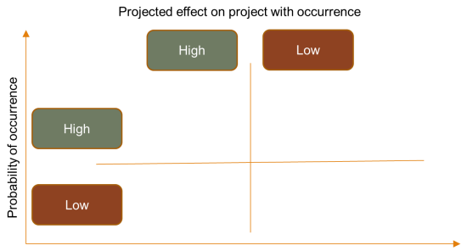

| Mitigation  Strategy | A Mitigation Strategy should be created for any risk deemed probable to occur and dangerous enough to address. |
| --- | --- |

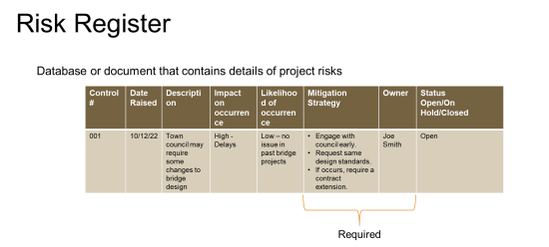

20 most common risk categories of which to be aware of (When one of these categories is identified as being active, you should determine a mitigation strategy as soon as possible):

1. Purchase and Need not well-defined.

2. Incomplete project design and deliverable definition.

3. Difficulty in defining and understanding project schedules.

4. Risk related to budget.

5. Resistance to change.

6. Risks related to resources.

7. Lack of control over staff priorities.

8. Risk factors related to disputes.

9. Unplanned work risk.

10. Communication issues.

11. Risk related to errors.

12. Escalating project conflicts not reported in a timely manner.

13. Delay in projects.

14. Increased workload due to policy changes, direction or statutes.

15. Health and safety.

16. Change in exchange rates.

17. Quality-related risk.

18. Resource supplier’s risk.

19. Risk related to partners.

20. Market-based risk.

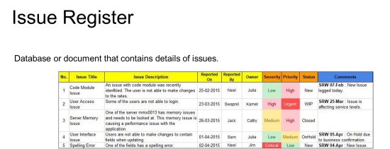

Can a risk also be an issue at the same time? ___No____

Can this be listed in both the risk register and issue register at the same time? __Yes____

Why or why not?

__Issues start of as risk and because of this would be listed in the risk registry. But once the risk occurs and becomes an issue they are then placed in the issue registry. You would not alter the original risk registry because it would make it appear as if you had no idea the issue may occur. So they would be in both registries.

**Relationship of Risk to Issue**



| Focused on the present.  Always negative.  Documented in Issue Register.  Response will be “issue work- around” if not correctable. | * Evaluated for future. * Positive or negative. * Documented in Risk Register. * Response performed based on “risk response planning.” |
| --- | --- |

| Stakeholder | any entity with an interest in the outcome of a project. |
| --- | --- |
| Customer | the entity that pays for a service or product. |
| User | the entity that consumes/utilizes a service or product. |
| Supplier | entity that provides products and services used in the creation or delivery of products or services to the end customer. |
| Service Provider | this entity provides services to customers and users to enhance business productivity. |

**Factors in determining the level of stakeholder involvement:**

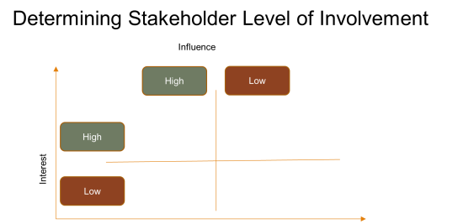

| RACI Usage | Used to identify stakeholders and their level of engagement |
| --- | --- |
| R— | Responsible for correct execution |
| A— | Accountable for final result |
| C— | Consulted to provide additional knowledge and information |
| I— | Informed or kept up to date regarding the process |

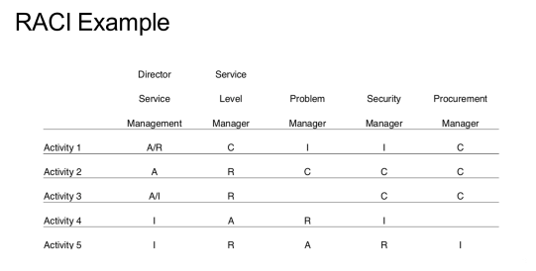

What is the #1 rule for using a RACI matrix?

There can only be one “A” (Accountable) in each Activity line.

**Every business looks to attain three things**

1. ___Achieve Objective_______
2. ___Manage Risks____________
3. ____Have fully utilized resources_______

The concept of value is determined by three items:

| Circumstances | Needs or wants | Perception |
| --- | --- | --- |

Why do we want to control the customer’s perception of the value of our deliverables?

Because value is defined by the customer's perspective and if the perception is poor we lose value.

Utility & Warranty

| Use Purpose | Use Purpose |
| --- | --- |
| * Fit for purpose (works as designed). * Improves probability of achieving outcomes. * Improves customer performance capability. * Reduces customer constraints. | * Availability – When needed. * Capacity – Adequate for business needs. * IT Service Continuity – Major disruption recovery. * Security – Are Customer assets secure? |

Who’s opinion of value is the only opinion that matters? Customers

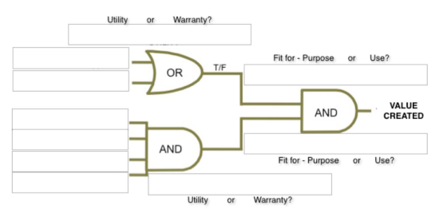What happens when an organization fails to deliver value? Failure of project

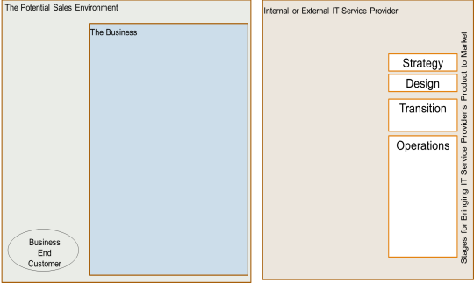

**Service Provider Types**

| Internal Service Provider |
| --- |
| Shared Services Unit |
| External Service Provider |